Summer is here and normally lots of us would be getting ready for our holidays/ days at the beach. Even though this year is going to be a bit different we still want to celebrate Summer time! Our topic this half term is seasides, so hopefully this will get you feeling nice and summery. Fingers crossed wekeep having this wonderful weather too! Here’s this week’s planning for you. Just go at your own pace; remember that a lot of the work we do during a normal day is play based, if the children are playing, exploring, building, making, creating both indoors and outdoors then they are learning! I hope everyone is well and happy! Don’t forget to have a look at the development matters objectives 40-60 months and the Early Learning goals; these are the objectives we are working on with the children at the moment. Everything we are doing centres around them achieving these goals.

Week 1: Monday | Tuesday | Wednesday | Thursday | Friday
Phonics- The children will still benefit from recapping phase 3 sounds in lots of different ways so for this week continue with this- see below this table for ideas.  Revise previously taught sounds- use the flash cards in pack/ Phonicsplay.co.ukwww.bbc.co.uk/bitesize/topics/zvq9bdm/articles/zh828xs  Kims game- Seasides  Introduction to the topic- Don’t tell the children that we are looking at seasides yet. See if they can guess the theme from the items you choose.  First introduce the children to using commas in a list, give them an example e.g. make a little shopping list with them.  I thought you might like to play Kim’s game today- collect things which you might associate with seasides/ holidays from around your house, place them on a tray then hide them under a cover. Reveal them to the children for 1 minute- then cover them up again, get the children to list as many items as they can remember sounding out the words themselves.  A nice variation of this is to hide items around your garden/ house and then go on a memory walk, get the children to spot the items/pictures on the way and then once back see how many they can remember. I bet they would enjoy setting one up for you too. | Phonics  Revise previously taught sounds- use the flash cards in pack/ Phonicsplay.co.uk  See below for phase 3 recap ideas.  Maths estimation games-  Estimation is a really fun area of maths for the children- for estimation I always explain why being able to estimate things is important and getting the right answer exactly doesn’t matter it’s about having a good guess. I give examples of situations you might need to do this e.g. buying sweets for the children in our class or measuring the length of a material they need to buy to make something out of.  Next I set up jars/ containers and put different amounts of things in them e.g. pasta, sweets, cereal (whatever you can get your hands on and get them to estimate the amount in each container- make it a game, if they have siblings who is the closest to getting it right? You could make a tally of points and add them up at the end to find out the winning estimator! | Phonics  Revise previously taught sounds- use the flash cards in pack/ phonicsplay.co.uk  See below for phase 3 recap ideas.  Literacy-Making a list  Today, you are going to make a list of things you might need to take with you to the seaside, try to sound out the words as independently as you can.  Remind the children about using commas in a list. Once they have written their list it might be fun to have a little competition/ scavenger hunt to see who can find each item on the list the quickest and pack them in a bag ready for their adventure. | Phonics  Revise previously taught sounds- use the flash cards in pack/ phonicsplay.co.uk  See below for phase 3 recap ideas.  Literacy – Beach Day!!  Continuing on from yesterday I thought it might be fun to set up your own little pretend seaside right in your own back garden. Have a beach day, then write a postcard to someone you love telling them all about it. (I hope the weather is nice enough) If you don’t have a garden or it is raining outside, you could set up a miniature beach on a little tray for your toy figures to enjoy.  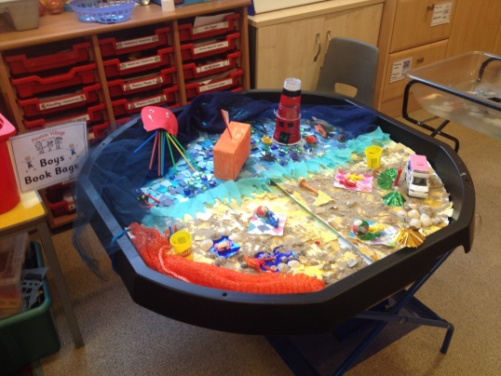  There is a postcard template for you to download on the webpage. | Phonics  Revise previously taught sounds- use the flash cards in pack  Tricky words- see instructions below.  Estimation station.  Roll up, roll up it’s time to make your own estimation station- today let the children be the ones to create their own estimation station (sorry if it gets messy) then you can be the ones to make estimates- they will count out the things in each container and announce the overall winner.  I have uploaded a crown for them to colour in as a prize for the winner! Enjoy!

Phonics
We have covered all of the phase 3 sounds now, so the best thing to do for the next couple of weeks is to go back and recap. Here are a few ideas of games you might like to play to practise the sounds:
- If you have one, get a dice and stick on some of the sounds we have covered starting at the beginning of phase 3- (I will upload a sheet with them all on) roll the dice and get the children to come up with/ practise writing a word with the sound they have landed on.
- Hide sounds around the house and play hide and seek, see if they can name the sound they have found.
- Put different words around the room with some of the phase 3 sounds on ask the children to run and find you a word with ‘ch’ in it.
- Go to phonics play- select the new version of the website, there are lots of games there for you to practise phase 3 sounds.
- Give the children a sound; get them to collect things from around the house which have that sound in them.
- You could also just pop 3 sounds on a sheet of paper and see how many of each you can think of.

These are just a few ideas I will upload more next week, I will also upload some sheets from Twinkl that the children could have a go at for practise as well.
Extra ideas:
Victorian Seasides
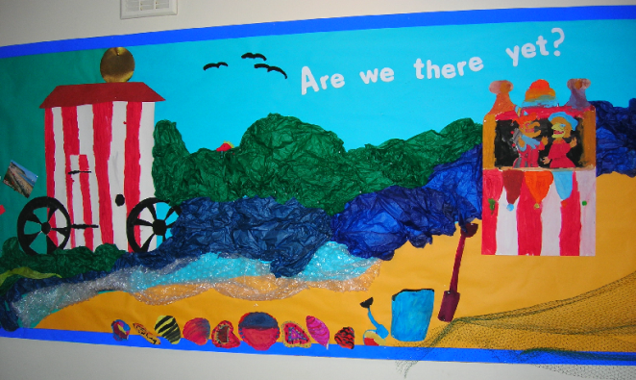
I thought it would be fun to have a look at what it might have been like to go to the seaside for Victorian children. Have a look on a timeline at how long ago the Victorians were alive. Remind the children about the fact that trains had just been made available to people so this meant that they could start thinking about going on holiday to the seaside. Before this normal people would have really just stayed in their own towns. (We can realte to this a little now!) Ask them how they will feel when they can finally get back to normal/ compare with how the Victorian chidlren felt when they could visit the beach for the first time. Listen to the following audio clip together and talk about it. https://www.bbc.co.uk/teach/school-radio/audio-stories-victorian-seaside/zfxjkmn. Now have a look at the PowerPoint together. If you would like an extension activity download the past and present comparison activity, you will find the link on the webpage.

Also don’t forget:
You ,might like to make your own little ocean tuft spot area to play in- have a look at this for inspiration- 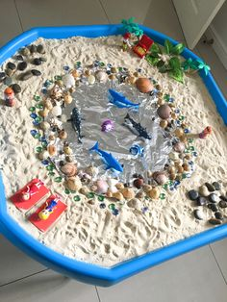
- Keep practising your tricky words- go onto YouTube and watch the tricky word song for both phases 2 and 3- then see how many of them you can spell without looking, do this as many times as you can.
- Practise letter formation and number formation (make sure your numbers are the right way round)
- You should still have some of the number maths resources I gave you in your pack; Keep practising making addition equations for each numicon, order numbers to 20 and use the numicon to help you solve addition/subtraction equations.
- Use the numicon to make teen numbers and work out how many tens/ units there are in each number.
- Number blocks on Cbeebies is a great resource for the children’s maths.
- Practise throwing underarm- don’t forget the technique we have been practising, see if you can catch a large ball, how many times can you bounce a ball without losing control?
- Practise kicking a ball, make yourself a little course to kick the ball around, can you control it?
- Keep role playing different things e.g. pretend to be super heroes etc.
- Go in to your garden, can you spot any birds/ other wildlife? Make a tally of what you see.
- Calling all authors/illustrators, design a front cover for your favourite book/your own story- maybe even have a go at writing one for me!
- Review a book that you have read- see resource in pack.

