Ahoy me hearties!!!- this week we are going all things pirate!! Its really imortant that you don’t read these plans to the children- each day I am going to put a new message from Captain Ash on our webpage for the children to read and on it will be the task for the day. However, I have still made you a timetable below so that you know what is coming! Enjoy! Just go at your own pace; remember that a lot of the work we do during a normal day is play based, if the children are playing, exploring, building, making, creating both indoors and outdoors then they are learning! I hope everyone is well and happy! Don’t forget to have a look at the development matters objectives 40-60 months and the Early Learning goals; these are the objectives we are working on with the children at the moment. Everything we are doing centres around them achieving these goals.
Phonics- Some of you have messaged to say that the children are ready to learn some new sounds which is great, if they are now confident with phase 3 then it’s fine for you to start looking at the next phases. Phase 4 is a funny one as the children don’t learn any new sounds with it, so I often mix a bit of four in with the new sounds in phase 5. If you go to phonics play and select teachers, then planning, you have access to all of their plans and can follow these; take it at your own pace though, they go through the sounds quite quickly, you might want to spend a few days on one sound.
If the children still need more time on Phase 2/3 then that’s absolutely fine too, we would still expect the majority to be working on phase 3 right now. Don’t forget the children pick things up at different speeds/times so there is absolutely no pressure at all. xxxxx

Week 2: Monday | Tuesday | Wednesday | Thursday | Friday
Phonics-  Revise previously taught sounds- use the flash cards in pack/ Phonicsplay.co.ukwww.bbc.co.uk/bitesize/topics/zvq9bdm/articles/zh828xs  recap phase 3  Literacy  Today the pirate will introduce himself and ask the children to help him find his lost parrot. He has heard that they are great writers and will make super descriptions for him as he doesn’t know how to write. If you send me their descriptions I will put them on the page as missing posters- link to a template to help them write their missing posters on the page. | Phonics  Revise previously taught sounds- use the flash cards in pack/ Phonicsplay.co.uk  See below for phase 3 recap ideas.  Maths  Pirate Dash Maths Game-  See below for the board layout. Today Captain Ash is going to set the children a game to play. The winner will be Pirate King/Queen for the day in your household! You will need 3 dice- the children can have fun making their own boards before they begin playing- you could make these outside in chalk if you like as well to play on a bigger scale. They take it in turns to roll their 3 dice and add up the total. If the total number is available on their board they can cross it off/cover it. The winner is the first to get their board filled up. To make this more difficult put numbers on the dice instead of dots. | Phonics  Revise previously taught sounds- use the flash cards in pack/ phonicsplay.co.uk  See below for phase 3 recap ideas.  Literacy-  Today Captain Ash will ask the children for their help to make a treasure map- they can be as imaginative as they like- give them ideas of what might be on the treasure map e.g. mermaids lagoon, sea monster lair, stepping stones of doom etc. Download the template and get the children to make their maps complete with labelling- don’t forget the most important thing x marks the spot! | Phonics  Revise previously taught sounds- use the flash cards in pack/ phonicsplay.co.uk  See below for phase 3 recap ideas.  Maths  Addition using a number line- not so pirate themed today- either draw a number line from 1-20 on a piece of paper or a big one outside. Teach the children how to count on using the number line starting with the biggest number first. If you have made a large number line outside the children can pretend to be frogs jumping along it. Then work out the addition equations on the sheet provided uploaded to the page. | Phonics  Revise previously taught sounds- use the flash cards in pack  Tricky words-If the children are now secure with phase 3 tricky words move onto Phase 4.  First phase 4 words-  Said, so, have, like, some, come,  Designing a boat- Today Captain Ash needs to acquire a boat to reach the island with the treasure on it. So the children will be asked to design a boat- look at the PowerPoint about pirate ships and ask the children to draw/ label Ash’s boat.  Pirate maths problems- today Captain Ash is going to need some help solving some pirate Maths addition
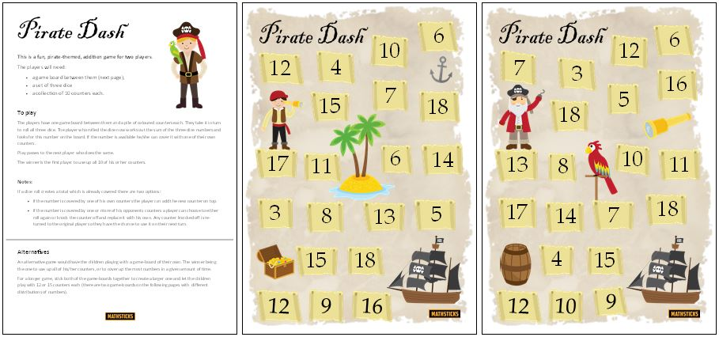
Phonics
We have covered all of the phase 3 sounds now, so the best thing to do for the next couple of weeks is to go back and recap. Here are a few ideas of games you might like to play to practise the sounds:
- If you have one, get a dice and stick on some of the sounds we have covered starting at the beginning of phase 3- (I will upload a sheet with them all on) roll the dice and get the children to come up with/ practise writing a word with the sound they have landed on.
- Hide sounds around the house and play hide and seek, see if they can name the sound they have found.
- Put different words around the room with some of the phase 3 sounds on ask the children to run and find you a word with ‘ch’ in it.
- Go to phonics play- select the new version of the website, there are lots of games there for you to practise phase 3 sounds.
- Give the children a sound; get them to collect things from around the house which have that sound in them.
- You could also just pop 3 sounds on a sheet of paper and see how many of each you can think of.

These are just a few ideas I will upload more next week, I will also upload some sheets from Twinkl that the children could have a go at for practise as well.

Extra ideas:
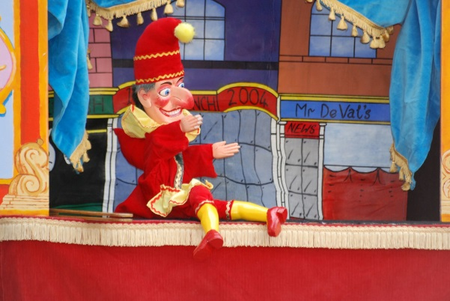
Punch and Judy
This week- continuing with the Victorian Seasides theme- we are going to look at the old Punch and Judy shows. Have a look at the powerpoint about Punch and Judy and then download the finger puppets I have put on the webpage. Let the children come up with and perform their own little theatre show for the family!

Also don’t forget:
- Keep practising your tricky words- go onto YouTube and watch the tricky word song for both phases 2 and 3- then see how many of them you can spell without looking, do this as many times as you can.
- Practise letter formation and number formation (make sure your numbers are the right way round)
- You should still have some of the number maths resources I gave you in your pack; Keep practising making addition equations for each numicon, order numbers to 20 and use the numicon to help you solve addition/subtraction equations.
- Use the numicon to make teen numbers and work out how many tens/ units there are in each number.
- Number blocks on Cbeebies is a great resource for the children’s maths.
- Practise throwing underarm- don’t forget the technique we have been practising, see if you can catch a large ball, how many times can you bounce a ball without losing control?
- Practise kicking a ball, make yourself a little course to kick the ball around, can you control it?
- Keep role playing different things e.g. pretend to be pirates.
- Go in to your garden, can you spot any birds/ other wildlife? Make a tally of what you see.
- Calling all authors/illustrators, design a front cover for your favourite book/your own story- maybe even have a go at writing one for me!
- Review a book that you have read- see resource in pack.

