Ahoy me hearties!!!- Keep looking out this week for messages from Captain Ash, I hope the chidlren are enjoying the activities. Just go at your own pace; remember that a lot of the work we do during a normal day is play based, if the children are playing, exploring, building, making, creating both indoors and outdoors then they are learning! I hope everyone is well and happy! Don’t forget to have a look at the development matters objectives 40-60 months and the Early Learning goals; these are the objectives we are working on with the children at the moment. Everything we are doing centres around them achieving these goals.
Phonics- as I said last week some of you have messaged to say that the children are ready to learn some new sounds which is great, if they are now confident with phase 3 then it’s fine for you to start looking at the next phases. Phase 4 is a funny one as the children don’t learn any new sounds with it, so I often mix a bit of four in with the new sounds in phase 5. If you go to phonics play and select teachers, then planning, you have access to all of their plans and can follow these; take it at your own pace though, they go through the sounds quite quickly, you might want to spend a few days on one sound.
If the children still need more time on Phase 2/3 then that’s absolutely fine too, we would still expect the majority to be working on phase 3 right now. Don’t forget the children pick things up at different speeds/times so there is absolutely no pressure at all. xxxxx

Week 3: Monday | Tuesday | Wednesday | Thursday | Friday
Phonics-  Revise previously taught sounds- use the flash cards in pack/ Phonicsplay.co.ukwww.bbc.co.uk/bitesize/topics/zvq9bdm/articles/zh828xs  Captain Ash has set sail over the weekend and is following their treasure map- but he has got a bit lost- can the children use their map to write a set of instructions for him to help find x marks the spot? When we are writing instructions we always begin with a time connective e.g. first, next, after that, then, finally, I will upload a PowerPoint for you to look at with the children to help explain time connectives to them. | Phonics  Revise previously taught sounds- use the flash cards in pack/ Phonicsplay.co.uk  See below for phase 3 recap ideas.  Oh no a Sea Monster has Trapped Captain Ash- imagine your Sea Monster and describe what he looks like- draw a picture first to help you! You can use the wanted poster template if you like which has been uploaded to the page. | Phonics  Revise previously taught sounds- use the flash cards in pack/ phonicsplay.co.uk  See below for phase 3 recap ideas.  Maths  To escape the sea monster he wants you to crack his codes- you will need to work out the answers to the subtraction equations (link on webpage) to get passed him. Use a number line to help you! | Phonics  Revise previously taught sounds- use the flash cards in pack/ phonicsplay.co.uk  See below for phase 3 recap ideas.  Phew, Captain Ash made it passed and reached the Island- have a look at the photo he has sent you, can you think of some sentences to describe the setting – we really want the children to start being independent, so if you can let them have a go at writing it with only a little support. | Phonics  Revise previously taught sounds- use the flash cards in pack  Tricky words- see instructions below.  Maths  Ash has found the treasure- first can you draw me a picture of what you think the treasure box looks like and what’s inside? Next complete the finding half activity as he wants to be fair and share the reward with you as a thank you for all of your help!

Phonics
We have covered all of the phase 3 sounds now, so the best thing to do for the next couple of weeks is to go back and recap. Here are a few ideas of games you might like to play to practise the sounds:
- If you have one, get a dice and stick on some of the sounds we have covered starting at the beginning of phase 3- (I will upload a sheet with them all on) roll the dice and get the children to come up with/ practise writing a word with the sound they have landed on.
- Hide sounds around the house and play hide and seek, see if they can name the sound they have found.
- Put different words around the room with some of the phase 3 sounds on ask the children to run and find you a word with ‘ch’ in it.
- Go to phonics play- select the new version of the website, there are lots of games there for you to practise phase 3 sounds.
- Give the children a sound; get them to collect things from around the house which have that sound in them.
- You could also just pop 3 sounds on a sheet of paper and see how many of each you can think of.

These are just a few ideas I will upload more next week, I will also upload some sheets from Twinkl that the children could have a go at for practise as well.

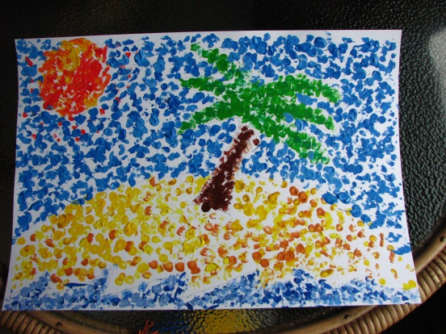

If you can get hold of some paint, this is a lovely easy activity for the children to have a go at; they can use fingers or earbuds to make the pointillism effect. Tell them that they are making Captain Ash’s treasure island.

Also don’t forget:
- Get the children to practise counting in 2’s and 10’s there are lots of songs on YouTube that they can sing along to.
- Keep practising your tricky words- go onto YouTube and watch the tricky word song for both phases 2 and 3- then see how many of them you can spell without looking, do this as many times as you can. If you have moved onto phase 4/5 start practising these as well.
- Practise letter formation and number formation (make sure your numbers are the right way round)
- You should still have some of the number maths resources I gave you in your pack; Keep practising making addition equations for each Numicon, order numbers to 20 and use the Numicon to help you solve addition/subtraction equations.
- Use the Numicon to make teen numbers and work out how many tens/ units there are in each number.
- Number blocks on Cbeebies is a great resource for the children’s maths.
- Practise throwing underarm- don’t forget the technique we have been practising, see if you can catch a large ball, how many times can you bounce a ball without losing control?
- Practise kicking a ball, make yourself a little course to kick the ball around, can you control it?
- Keep role playing different things e.g. pretend to be a pirate searching for treasure.
- Go in to your garden, can you spot any birds/ other wildlife? Make a tally of what you see.
- Calling all authors/illustrators, design a front cover for your favourite book/your own story- maybe even have a go at writing one for me!
- Review a book that you have read- see resource in pack.

