Hi everyone, normally we would be having sports day around this time, so for the next two weeks I am going to centre everything around this. We will get back to seasides again after these two weeks! Remember, as I say every week, go at your own pace; as you know a lot of the work we do during a normal day is play based, if the children are playing, exploring, building, making, creating both indoors and outdoors then they are learning! I hope everyone is well and happy! Don’t forget to have a look at the development matters objectives 40-60 months and the Early Learning goals; these are the objectives we are working on with the children at the moment. Everything we are doing centres around them achieving these goals.
Phonics- as I said last week some of you have messaged to say that the children are ready to learn some new sounds which is great, if they are now confident with phase 3 then it’s fine for you to start looking at the next phases. Phase 4 is a funny one as the children don’t learn any new sounds with it, so I often mix a bit of four in with the new sounds in phase 5. If you go to phonics play and select teachers, then planning, you have access to all of their plans and can follow these; take it at your own pace though, they go through the sounds quite quickly, you might want to spend a few days on one sound.
If the children still need more time on Phase 2/3 then that’s absolutely fine too, we would still expect the majority to be working on phase 3 right now. Don’t forget the children pick things up at different speeds/times so there is absolutely no pressure at all. xxxxx

Week 3: Monday | Tuesday | Wednesday | Thursday | Friday
Phonics-  Revise previously taught sounds- use the flash cards in pack/ Phonicsplay.co.ukwww.bbc.co.uk/bitesize/topics/zvq9bdm/articles/zh828xs  Maths  Today you are going to follow a set of challenges; I will upload them to the website along with a tally chart. Each member of the family will have 1 minute per member for every challenge (talk about the fact that there are 60 seconds in a minute) Tally every ones totals and work out the winner of each challenge. The overall winner will be the person who has won the most amount of challenges. This will help the children with counting skills, remind them about tally charts and get them thinking about ordering numbers from smallest to biggest. | Phonics  Revise previously taught sounds- use the flash cards in pack/ Phonicsplay.co.uk  See below for phase 3 recap ideas.  Maths  Using a tally chart again, ask people in your family what their favourite sport is. We will also do this with the children in school and put the results straight up on Tuesday morning- add our results from school into your chart and then make a bar graph to show the results. (Both the tally chart and graph template will be uploaded) | Phonics  Revise previously taught sounds- use the flash cards in pack/ phonicsplay.co.uk  See below for phase 3 recap ideas.  Literacy-  When I was little we always had a crazy obstacle course at school, (not dangerous of course) today get the children to design the craziest sports day obstacle course you dare to have a go at. Think outside the box- if the weather is nice paddling pools could even be involved. Draw the design and make a list of the equipment you need to make it. Good luck everyone. | Phonics  Revise previously taught sounds- use the flash cards in pack/ phonicsplay.co.uk  See below for phase 3 recap ideas.  Sports Day  Today is your official sports day! Time for all of the good old fashioned favourites, this will mean all of your family needs to get involved. If you can, maybe go and find a bigger space to do it on. In our sports day we have the egg and spoon, flat, quoit, sack/ pillow case and obstacle. | Phonics  Revise previously taught sounds- use the flash cards in pack  Tricky words- see instructions below.  Sports Day write up  Today you are working for the Halton Times Newspaper. Following yesterday’s sports day use the template on the webpage to write a report telling us what happened , make it funny; judging by what normally happens I’m sure that the mums and dads will have made you all laugh!
Phonics
We have covered all of the phase 3 sounds now, so the best thing to do for the next couple of weeks is to go back and recap. Here are a few ideas of games you might like to play to practise the sounds:
- If you have one, get a dice and stick on some of the sounds we have covered starting at the beginning of phase 3- (I will upload a sheet with them all on) roll the dice and get the children to come up with/ practise writing a word with the sound they have landed on.
- Hide sounds around the house and play hide and seek, see if they can name the sound they have found.
- Put different words around the room with some of the phase 3 sounds on ask the children to run and find you a word with ‘ch’ in it.
- Go to phonics play- select the new version of the website, there are lots of games there for you to practise phase 3 sounds.
- Give the children a sound; get them to collect things from around the house which have that sound in them.
- You could also just pop 3 sounds on a sheet of paper and see how many of each you can think of.

These are just a few ideas I will upload more next week, I will also upload some sheets from Twinkl that the children could have a go at for practise as well.
Extra ideas:
Making sports day banners
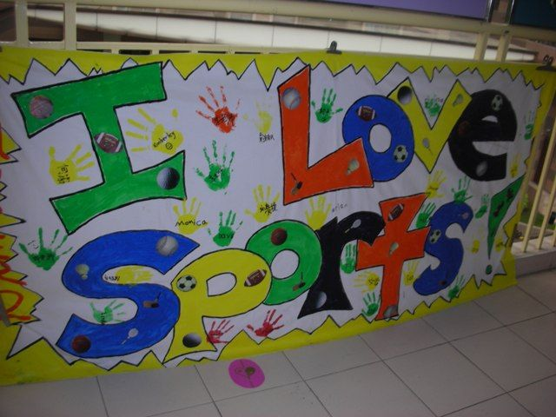 Make banners to put up for your sports day on Thursday!

Also don’t forget:
- Keep practising your tricky words- go onto YouTube and watch the tricky word song for both phases 2 and 3- then see how many of them you can spell without looking, do this as many times as you can.
- Practise letter formation and number formation (make sure your numbers are the right way round)
- You should still have some of the number maths resources I gave you in your pack; Keep practising making addition equations for each numicon, order numbers to 20 and use the numicon to help you solve addition/subtraction equations.
- Use the numicon to make teen numbers and work out how many tens/ units there are in each number.
- Number blocks on Cbeebies is a great resource for the children’s maths.
- Practise throwing underarm- don’t forget the technique we have been practising, see if you can catch a large ball, how many times can you bounce a ball without losing control?
- Practise kicking a ball, make yourself a little course to kick the ball around, can you control it?
- Keep role playing different things e.g. pretend to be super heroes etc.
- Go in to your garden, can you spot any birds/ other wildlife? Make a tally of what you see.
- Calling all authors/illustrators, design a front cover for your favourite book/your own story- maybe even have a go at writing one for me!
- Review a book that you have read- see resource in pack.

