Reading list for year 3 ( age 7-8 )
The World According to Humphrey  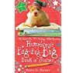  Betty G. Birney | Harry the Poisonous Centipede  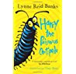  Lynne Reid Banks | Dilly the Dinosaur  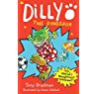  Tony Bradman | The Invisible Boy  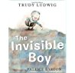  Trudy Ludwig | Flat Stanley  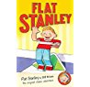  Jeff Brown
The Secret World of Polly Flint  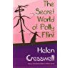  Helen Cresswell | Fantastic Mr Fox  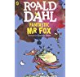  Roald Dahl | Wilf the Mighty Worrier Saves the World  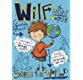  Geargia Pritchett | The Magic Finger  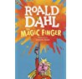  Roald Dahl | Dog in the Dungeon  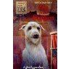  Lucy Daniels
Willa and Old Miss Annie  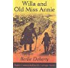  Berlie Doherty | My Naughty Little Sister  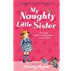  Dorothy Edwards | The Diary of a Killer Cat  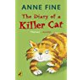  Anne Fine | Picasso Perkins  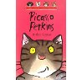  Adele Geras | The Reluctant Dragon  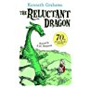  Kenneth Grahame
The Charlie Moon Collection  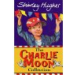  Shirley Hughes | Lullabyhullaba  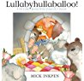  Mick Inkpen | All Because of Jackson  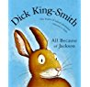  Dick King-Smith | First Greek Myths  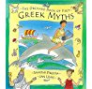  Saviour Pirotta | Winnie the Pooh Collection  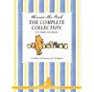  A.A. Milne
Mrs Cockle’s Cat  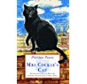  Phililppa Pearce | Mrs Pepperpot Stories  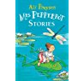  Alf Proysen | Unusual Day  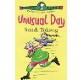  Sandi Toksvig | The Owl Who Was Afraid of the Dark  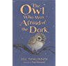  Jill Tomlinson | Pippa Longstocking Gift Edition  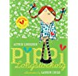  Astrid Lindgren
The Cat in the Hat  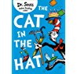  Dr. Seuss | Who’s in the Loo?  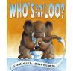  Jeanne Willis | The True Story of the 3 Little Pigs  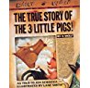  Jon Scieszka | It was a Dark and Stormy Night  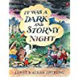  Janet Ahlberg | The Railway Cat  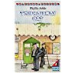  Phyllis Arkle
The Giving Tree  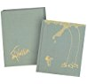  Shel Siverstein | Where the Wild Things Are  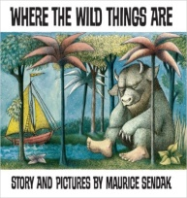  Maurice Sendak

