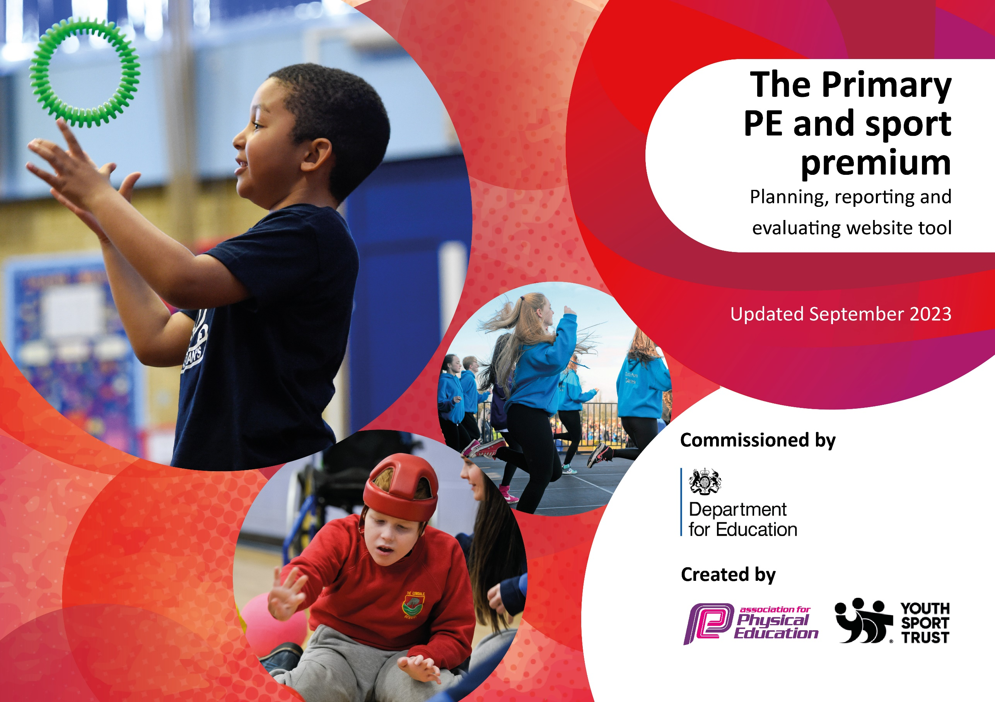

Review of last year’s spend and key achievements (2022/2023)

Activity/Action | Impact | Comments
St Wilfrid’s has achieved the School Games Gold award 3 times in a row. This Year we have achieved School Games Platinum Mark for the first time.  Our running track has been resurfaced and made all weather. This is used to help children accomplish the exercise quota they require on a daily basis. We also purchased a range of equipment for both curriculum and breaktime provision.  Once again, we bought into the Lancaster School Sports Network.  All KS2 children taking part in school swimming and water safety skills.  Teachers received CPD- Morecambe Community Sports worked alongside members of staff in lesson times and lunch times. We also employed a rugby coach for all KS2 classes for staff to team teach the necessary skills for invasion games. Both P.E. leads attended a variety of training and then led in school staff training to support members of staff further.  Morecambe Community Sports provided a lunch time club for KS2, two days a week to allow children to practise FMS skills taught in P.E. sessions and also promote school values amongst the children.  We continued to buy into our Orienteering units of work with the aim of increasing children’s 60 active minutes throughout the day.  P.E. app purchased to help the delivery and assessment of P.E. in all Key Stages.  All Key Stage 1 children have had cycle skill sessions and Y5 and 6 children have completed bikeability training.  Throughout the year school has provided a range of extra-curricular clubs including rugby, running, athletics, football, dance, ballet, multiskills, netball, rounders and fitness.  Most KS2 children have participated in competitions, including a large number of children who attended the Salt Ayre sports festival. Other competitions included; Elleray cross country, glow dodgeball, local swimming gala, local football competitions and athletics. We also have our own sports day/ festival and Intra school football festival for KS2.  15 children from Y5 were trained as young leaders and spent their breaktimes with KS1 children completing activities and playing games. | As a result of being awarded the platinum mark the profile of P.E. has been raised across school.  As a result of the track, all pupils are engaged in regular physical activity. We set the children our marathon running challenge- all children aiming to achieve the length of a marathon around the track over time. Some children took part in our extra-curricular running club and these children competed in our annual cross-country competition in Windermere.  Being part of the network help us to achieve all 5 key indicators. Staff are offered lots of opportunities for CPD, pupils are offered a broader experience of sports and all children are engaged in regular physical activity.  94% percent of St Wilfrid’s children left school last year being able to swim competently, confidently and proficiently over a distance of at least 25 metres and 100% could perform safe self-rescue in different water-based situations  This helped to meet key indicator number 1, increasing confidence, knowledge and skills of all staff in teaching P.E.  Having these lunchtime clubs ensured that all KS2 children had the opportunity to engage in regular physical activity. They also provided a range of sporting experiences for them. The children have really benefited from talking about the values and demonstrating sportsmanship. This has led to more enjoyable playtimes.  Teachers used the orienteering resources in both P.E. and topic work, helping to achieve their 60 active minutes.  Staff used the app to plan and deliver P.E. lessons throughout school. Staff also used the app to help assess Fundamental Movement Skills from EYFS to Year 2. This data helped to inform each term’s subsequent planning.  The children who undertook cycle sessions all gained in confidence with many who could not pedal independently at the start of the sessions, being able to do so by the end of their sessions.  As a result of these clubs a large percentage of children have been engaged in regular physical exercise and achieved an active 60 minutes in a day.  These competitions helped to increase children’s participation in competitive sport. Particularly across KS2.  The impact of this was helping to engage KS1 pupils in regular physical activity and ensuring that their playtimes were adding to their active 60 minutes a day. | In the next academic year, we will aim to keep the platinum mark.  Running around the track remains a high priority throughout school in the new academic year and is built into their everyday life, helping them to build healthy habits.  As a result of signing up the children were entered into a variety of competitions including the sports festival, where we took teams for cheerleading, cricket, rugby, dodgeball and athletics. They also provided us with opportunities to engage pupils in physical activity including football and give them a broader experience of sports. The SSN also provided opportunities for inclusive sports for all children.  Funding is not used to pay for swimming lessons. In the academic year 2023/24 we plan to introduce more water safety skills and skills for being on pool side to KS1 children.  We will continue to use MCS to work alongside various members of staff next year with the aim of achieving key indicator 1.  We will be continuing to use funding for these lunchtime clubs next year to ensure that pupils are engaged in regular physical activity.  As we have a lot of new members of staff, we will be leading a workshop to help them with and use the orienteering scheme of work; again, with the aim of meeting key indicator 1.  After attending training on how to best use the app we led a staff meeting to introduce the new features to all teaching staff. We also ensured that all members of staff understood the planning, teaching and assessment that needs to be recorded in the app to ensure progression. We will continue to develop our use of the app, ensuring that it also helps us to ascertain data which will help us to engage all pupils in sport such as tracking clubs and competitions.  Next year we aim to continue with cycling sessions and also want to introduce Wheely Wednesdays and Park and Stride days.  Next year we will continue to assess clubs provided and give a broad experience of sports to the children. We will track attendance through the app and provide any children not engaged with a sport they would like to try.  Next year we want children to experience competitive sport and aim for a large percentage to represent school at some point in the year.  We will be training the next set of young leaders in Autumn Term 1.

Key priorities and Planning

Action – what are you planning to do | Who does this action impact? | Key indicator to meet | Impacts and how sustainability will be achieved? | Cost linked to the action
Provide children with a wider variety of curriculum sports and extra-curricular clubs with the aim of increasing participation and inclusion.  Continue to provide lunchtime sport sessions/activities for pupils.  We will continue to buy into the SSN.  Next year we want children to experience competitive sport and aim for a large percentage of KS2 to represent school at some point in the year. We will use the app to help us track data.  Continue partnership with other schools through Lancaster schools’ network and the Lancs and Heysham SSN; through these links children will get the chance to participate in a range of competitive sports.  To engage children in outdoor and adventurous activities we intend to introduce 2 day trips to an outdoor venue. One for a year group in KS1 and the other KS2. This will hopefully become a yearly trip which the children will look forward to and again encourage participation.  FMS will continue to be a priority for EYFS, Y1, Y2 and Y3  We will continue to buy into the Lancashire P.E. passport app. Staff to record assessment data and photos for evidence. We will also be using the app to record extra-curricular clubs and competitions to track pupil participation.  We plan to train new Young Leaders in the Autumn term to help run playtime activities for KS1. | Teaching staff, coaches and pupils  Lunchtime supervisors / teaching staff, coaches - as they need to lead the activity  pupils – as they will take part.  Teaching staff, SSN providers, coaches and pupils  Teaching staff, pupils, SSN providers.  Teaching staff and pupils.  Teaching staff and pupils.  Teaching staff and pupils.  Teaching staff and pupils.  Lunchtime supervisors / teaching staff, coaches - as they need to lead the activity  pupils – as they will take part. | Key indicator 2 -The engagement of all pupils in regular physical activity  Key indicator 3- Raising the profile of P.E.  Key indicator 4- offer a broader and more equal experience of a range of sports and physical activities to all pupils  Key indicator 5- Increase participation in competitive sport  Key indicator 2 -The engagement of all pupils in regular physical activity – the Chief Medical Officer guidelines recommend that all children and young people aged 5 to 18 engage in at least 60 minutes of physical activity per day, of which 30 minutes should be in school.  Key indicator 4: Broader experience of a range of sports and activities offered to all pupils.  Being part of the network help us to achieve all 5 key indicators.  Key indicator 5- Increase participation in competitive sport  Key indicator 5- Increase participation in competitive sport  Key indicator 2 -The engagement of all pupils in regular physical activity  Key indicator 4- offer a broader and more equal experience of a range of sports and physical activities to all pupils  Key indicator 2 -The engagement of all pupils in regular physical activity  Key indicator 2 -The engagement of all pupils in regular physical activity  Key indicator 3- Raising the profile of P.E.  Key indicator 4- offer a broader and more equal experience of a range of sports and physical activities to all pupils  Key indicator 5- Increase participation in competitive sport  Key indicator 2 -The engagement of all pupils in regular physical activity  Key indicator 3- Raising the profile of P.E.  Key indicator 4- offer a broader and more equal experience of a range of sports and physical activities to all pupils | More pupils will meet their physical activity goal. By offering a wider variety of clubs children who may not always participate in extra curricular activities will hopefully sign up.  More pupils meeting their daily physical activity goal, more pupils encouraged to take part in PE and Sport Activities.  Staff are offered lots of opportunities for CPD, pupils are offered a broader experience of sports and competitions and all children are engaged in regular physical activity.  Children will be proud to represent the school and this should give them incentives to participate in sporting activities, helping them to achieve their active daily minutes and promoting healthy lifestyles.  As above  Children will be given the opportunity to experience outdoor and adventurous activities in an exciting setting, encouraging them to engage in physical activity.  We will purchase more sustainable equipment for Early Years and KS1 to practise their FMS skills in continuous provision.  The app will support teachers in their P.E. lessons. By assessing the children using the app we will be able to identify areas to target and help all children to become confident and physically literate. By keeping a record of attendance to clubs we will be able to see those children who are less likely to join and target their needs.  By training the young leaders we are giving responsibility to the Y5’s and they will then support the younger children in their fundamental movement skills. This gives them the opportunity to be good role models. | £3400  £1600 costs for additional coaches to support lunchtime sessions.  £2150  £200  TBC  TBC- This is a working document and will evolve throughout the year  TBC  Training the young leaders comes with our SSN package.

CPD for teachers including team teach sessions with Morecambe community sports.  We will provide cycle skill sessions for all children in KS1 and Y5 will have bikeability. We also aim to introduce Wheely Wednesdays and Park and Stride days.  We will introduce key swimming skills in Y1 and 2 so that children are ready to swim when they reach KS2. We will be highlighting the importance of water safety skills due to our location.  We will purchase equipment for both curriculum and extra-curricular activities as needed. | All staff.  All staff.  Teaching staff and pupils.  Teaching staff | Key Indicator 1: Increased confidence, knowledge, and skills of all staff in teaching PE and sport.  Key indicator 5: Increased participation in competitive sport.  Key indicator 2 -The engagement of all pupils in regular physical activity  Key Indicator 1: Increased confidence, knowledge, and skills of all staff in teaching PE and sport.  Key indicator 4- offer a broader and more equal experience of a range of sports and physical activities to all pupils  All 5 key indicators | Teachers will be more confident to deliver effective PE, supporting pupils to undertake extra activities inside and outside of school.  Cycle skill sessions help the children with their gross motor skills. Riding a bike is an excellent source of exercise and promotes leading a healthy lifestyle. Once the children can ride confidently it becomes part of their everyday life and contributes to their active 60 minutes a day.  By introducing key swimming skills out of the water in KS1 we are preparing the children for their swimming sessions in KS2.  Staff require the necessary equipment to teach their lessons both in curriculum and extra-curricular activities. | £5000 for 5 teachers to undertake CPD.  £900 (Approx)  TBC for equipment.  TBC

Key achievements 2023-2024- To be completed at the end of the year.

Activity/Action | Impact | Comments

Swimming Data
Meeting National Curriculum requirements for swimming and water safety.

Question | Stats: | Further context  Relative to local challenges
What percentage of your current Year 6 cohort can swim competently, confidently and proficiently over a distance of at least 25 metres? | %
What percentage of your current Year 6 cohort can use a range of strokes effectively [for example, front crawl, backstroke, and breaststroke]? | %

What percentage of your current Year 6 cohort are able to perform safe self-rescue in different water-based situations? | %
If your schools swimming data is below national expectation, you can choose to use the Primary PE and sport premium to provide additional top-up sessions for those pupils that did not meet National Curriculum  requirements after the completion of core lessons. Have you done this? | Yes/No
Have you provided CPD to improve the knowledge and confidence of staff to be able to teach swimming and water safety? | Yes/No

Signed off by:

Head Teacher:
Subject Leader or the individual responsible for the Primary PE and sport premium:
Date:

